# Testing

The evaluation process of a software in order to observe and identify possible differences between input given by the user and the expected output. It is an essential part of software development process. In this project, I have implemented the following types of testing process.

## White box testing

White Box Testing is a testing process where the functional aspect is left untouched and only the validation of internal code structure or working of an application is done. Various test cases are design in this phase of testing.

### Retrieving current user data after successful login via services

|  |  |
| --- | --- |
| Test ID | WT01 |
| Test Purpose | Retrieving current user data after successful login via services |
| Expected Result | User login successful |
| Actual Result | User login successful |
| Result | passed |

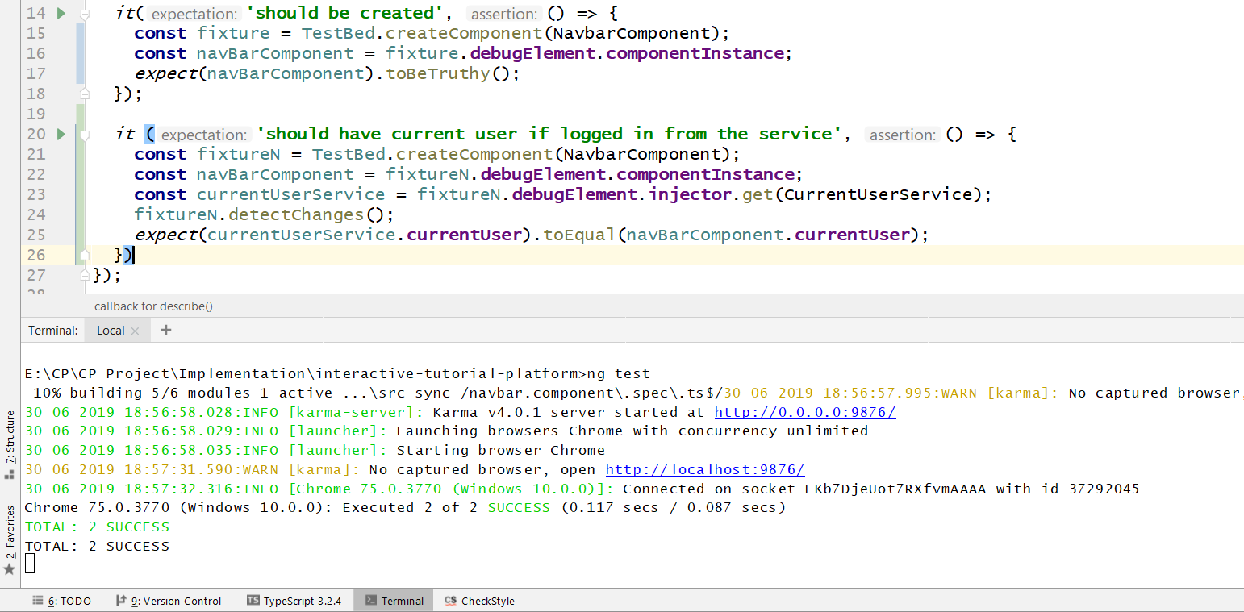

Figure 1: Unit Test case 1

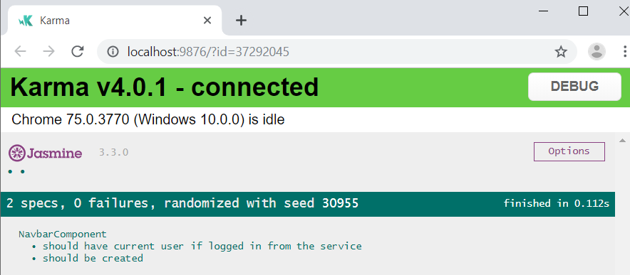

Figure 2: Unit Test case 1 result

### Adding new course content

|  |  |
| --- | --- |
| Test ID | WT02 |
| Test Purpose | Adding new course content |
| Expected Result | Successfully added course |
| Actual Result | Failed to add course |
| Result | Failed |

**Failed attempt**

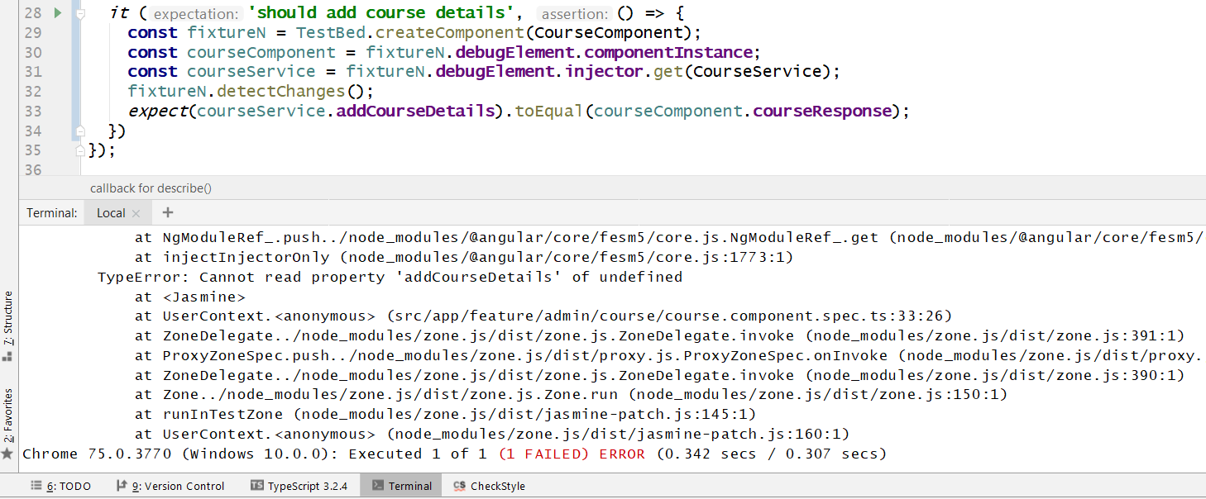

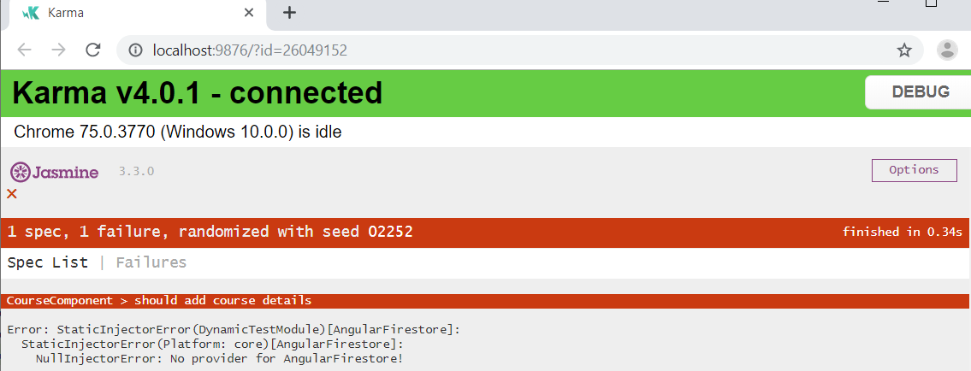

Figure 3: Test case 02 failed result

**Passed attempt**

The AngularFirestore Service which encompasses the entire firebase service package was not provided in the providers array (providers: []) in admin-module. The persisting loophole was overcome and the outcome was green.

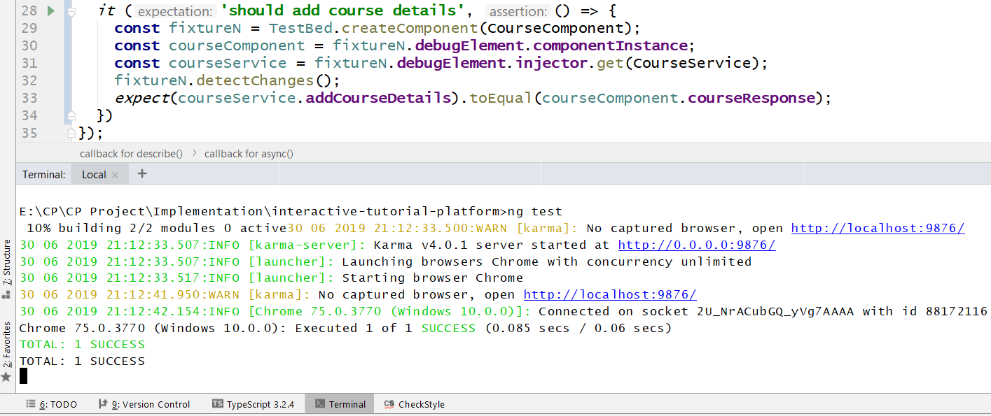

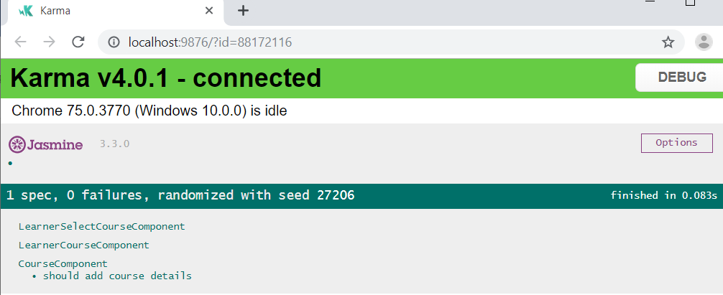

Figure 4: Test case 02 passed result

### Changing course status as read or unread

|  |  |
| --- | --- |
| Test ID | WT03 |
| Test Purpose | Changing course status as read or unread |
| Expected Result | Successfully changed status |
| Actual Result | Successfully changed status |
| Result | Passed |

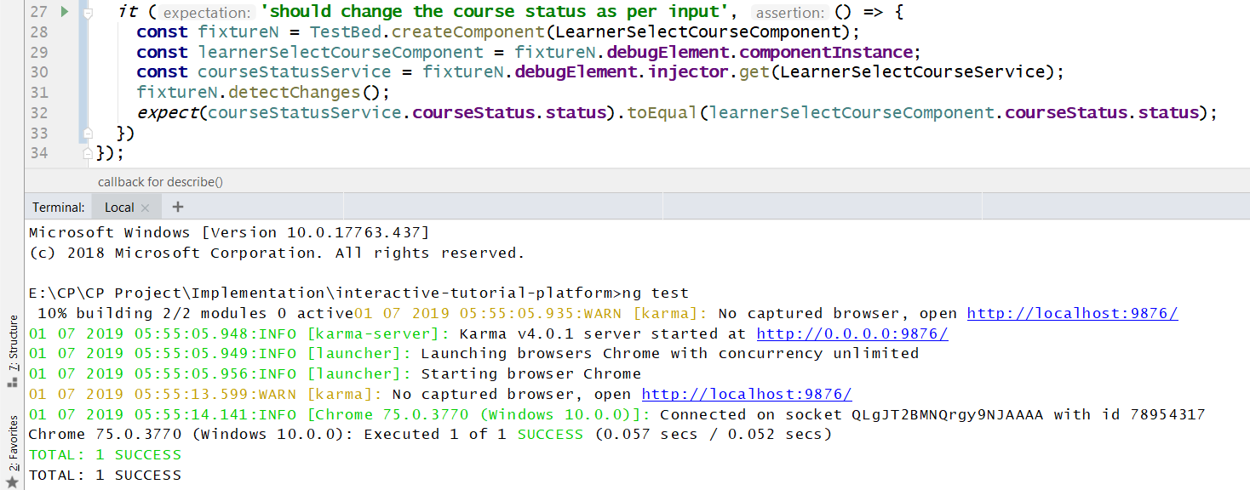

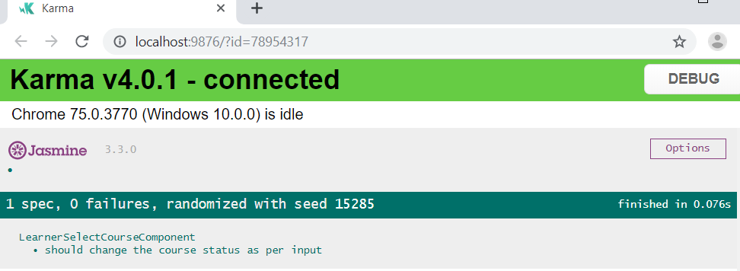

Figure 5: Test case 03 result

### Two-way binging of comment section as the user adds them

|  |  |
| --- | --- |
| Test ID | WT04 |
| Test Purpose | Two-way binding of comment section as the user adds them. |
| Expected Result | Successfully added comment |
| Actual Result | Successfully added comment |
| Result | Passed |

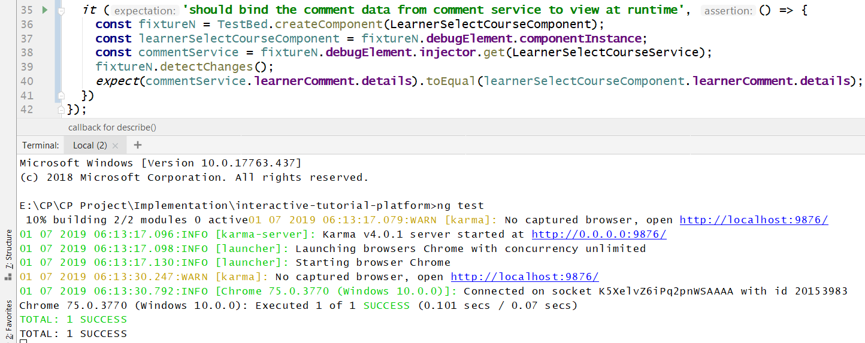

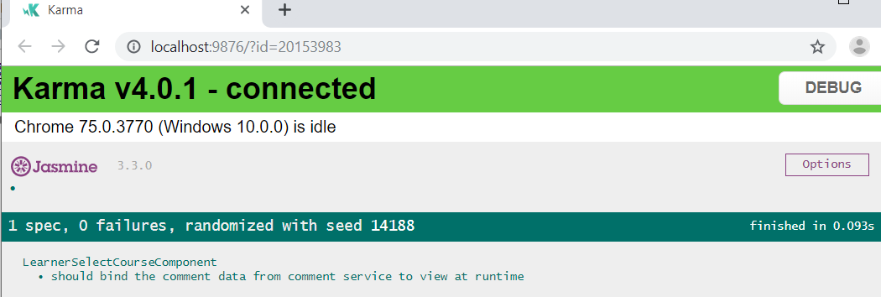

Figure 6: Test case 04 result

### Retrieving questions list for a particular course

|  |  |
| --- | --- |
| Test ID | WT05 |
| Test Purpose | Retrieving question list for a particular course |
| Expected Result | Successfully fetched course |
| Actual Result | Successfully fetched course |
| Result | Passed |

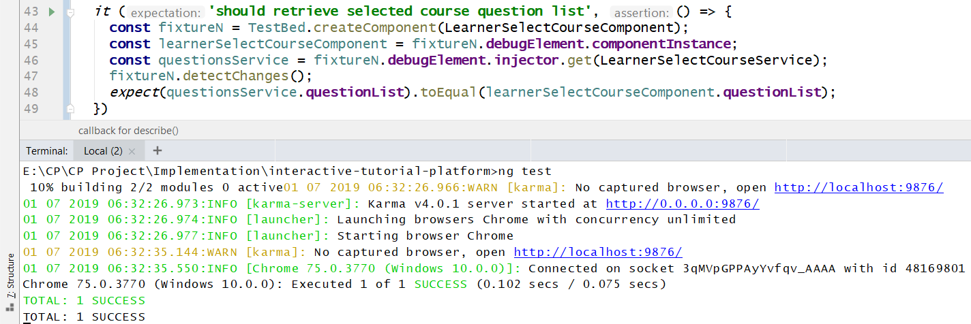

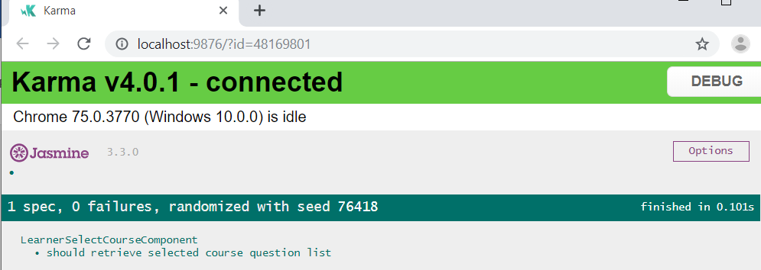

Figure 7: Test case 05 result

### Two-way binging for user’s obtained points after the user submits their answers

|  |  |
| --- | --- |
| Test ID | WT06 |
| Test Purpose | Two-way binding for user’s obtained points after the user submits their answers. |
| Expected Result | Successfully evaluated points |
| Actual Result | Successfully evaluated points |
| Result | Passed |

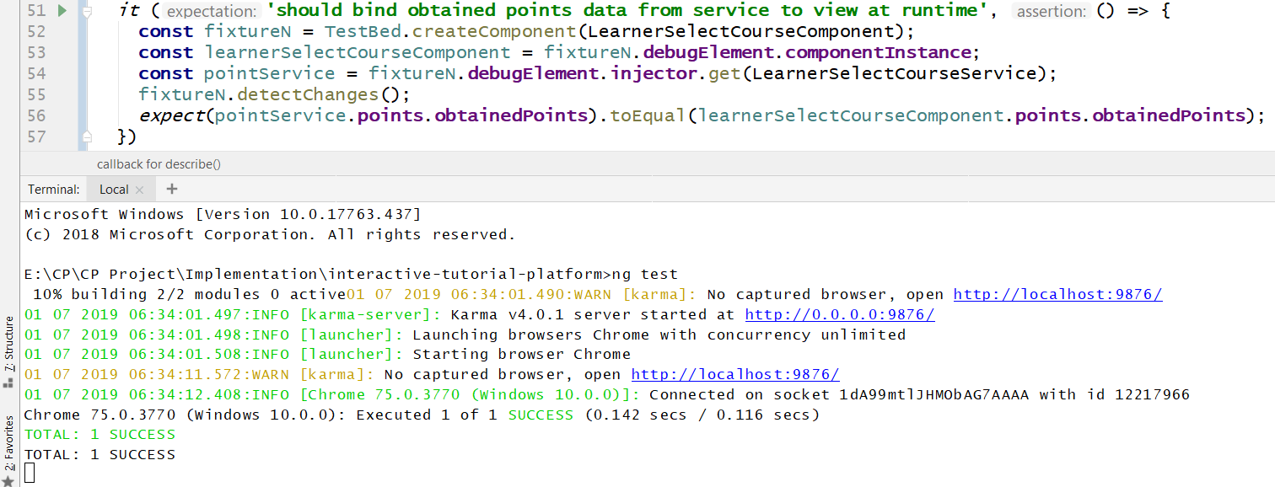

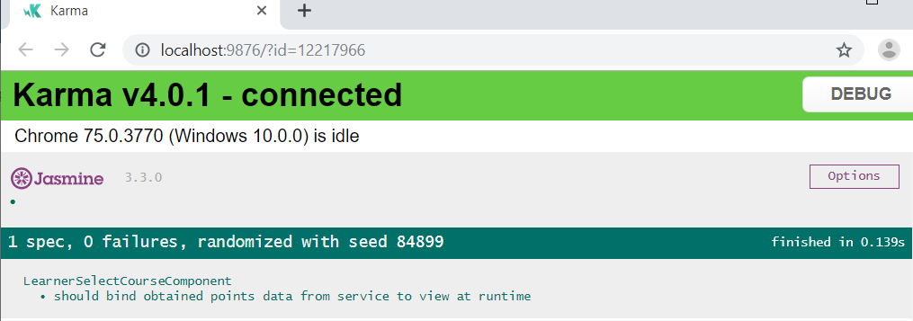

Figure 8: Test case 06 result

### Only allowing access to edit or delete comments left by that particular user

|  |  |
| --- | --- |
| Test ID | WT07 |
| Test Purpose | Only allowing access to edit or delete comments left by that particular user. |
| Expected Result | Edit access true |
| Actual Result | Edit access true |
| Result | Passed |

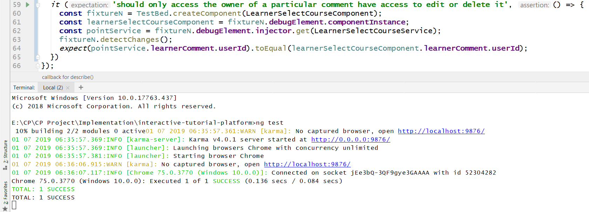

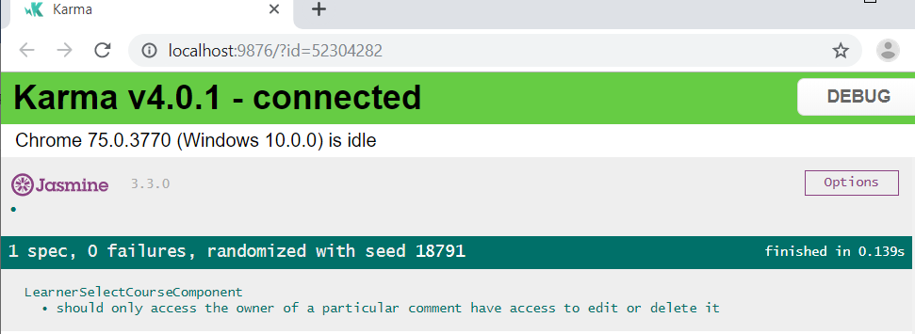

Figure 9: Test case 07 result

### Retrieving blog list for blog section on client end

|  |  |
| --- | --- |
| Test ID | WT08 |
| Test Purpose | Retrieving blog list for blog section on client end |
| Expected Result | Successfully fetched blog list |
| Actual Result | Successfully fetched blog list |
| Result | Passed |

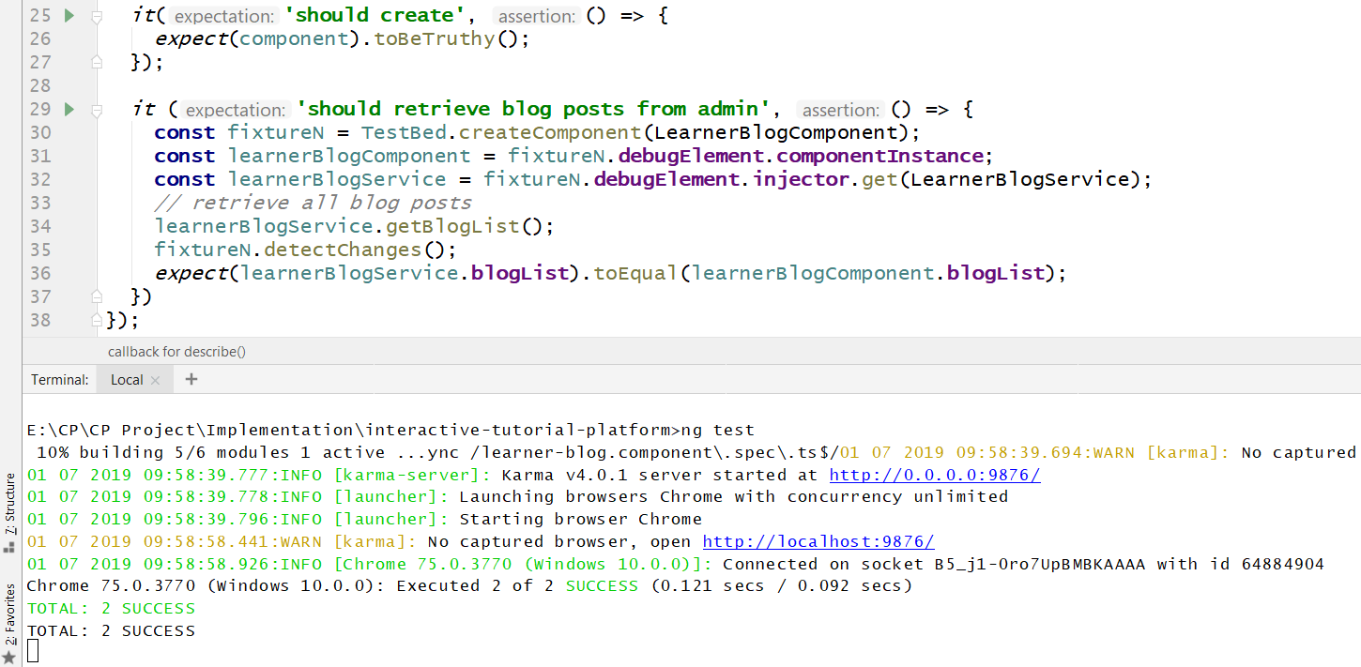

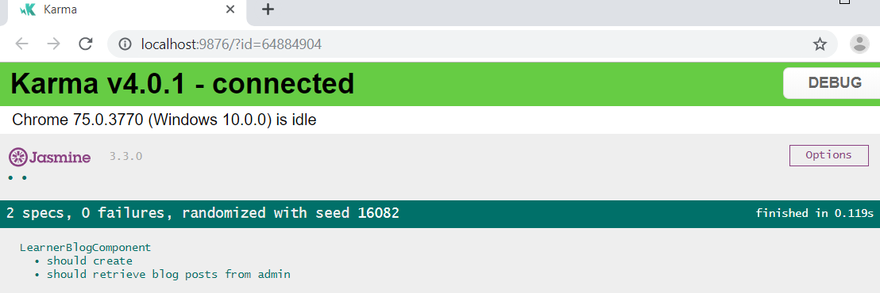

Figure 10: Test case 08 result

### Submitting feedback to the admin

|  |  |
| --- | --- |
| Test ID | WT09 |
| Test Purpose | Submitting feedback to the admin |
| Expected Result | Successfully sent feedback |
| Actual Result | Failed to send feedback |
| Result | Failed |

**Failed attempt**

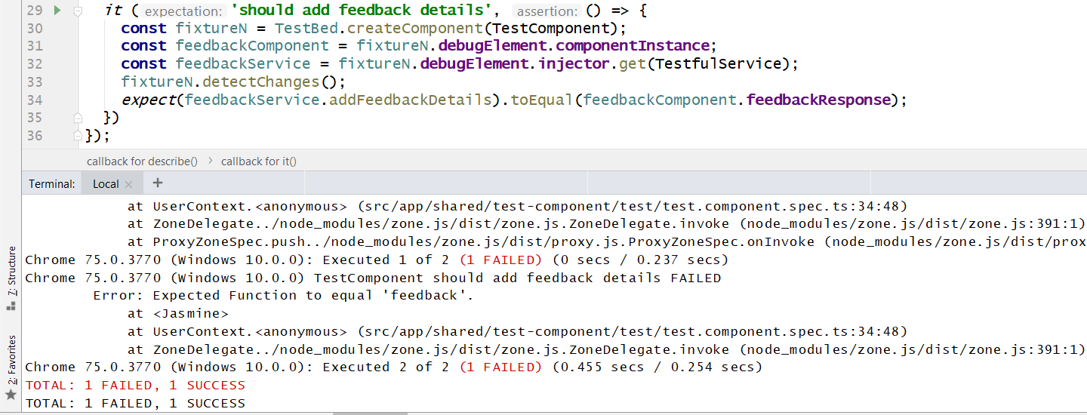

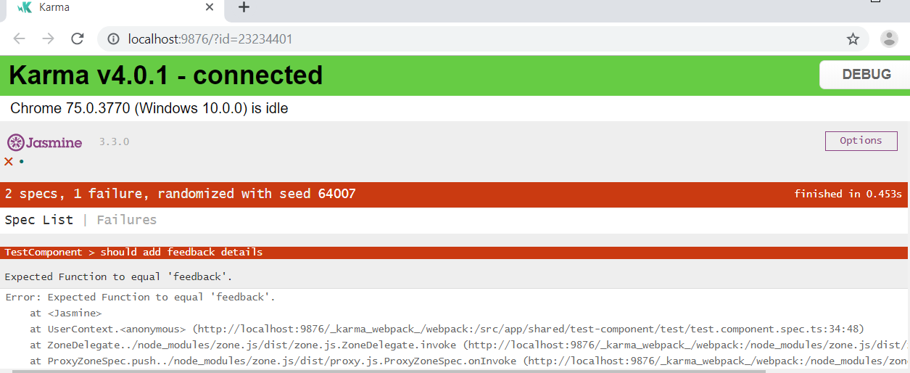

Figure 11: Test case 09 failed result

**Passed Attempt**

The subscribed value of feedback details did not match that of the response since the subscribed value wasn’t assigned to a variable. Therefore, the function conflicted with the response value. It was overcome by assigning the subscribed value to a variable as shown below.

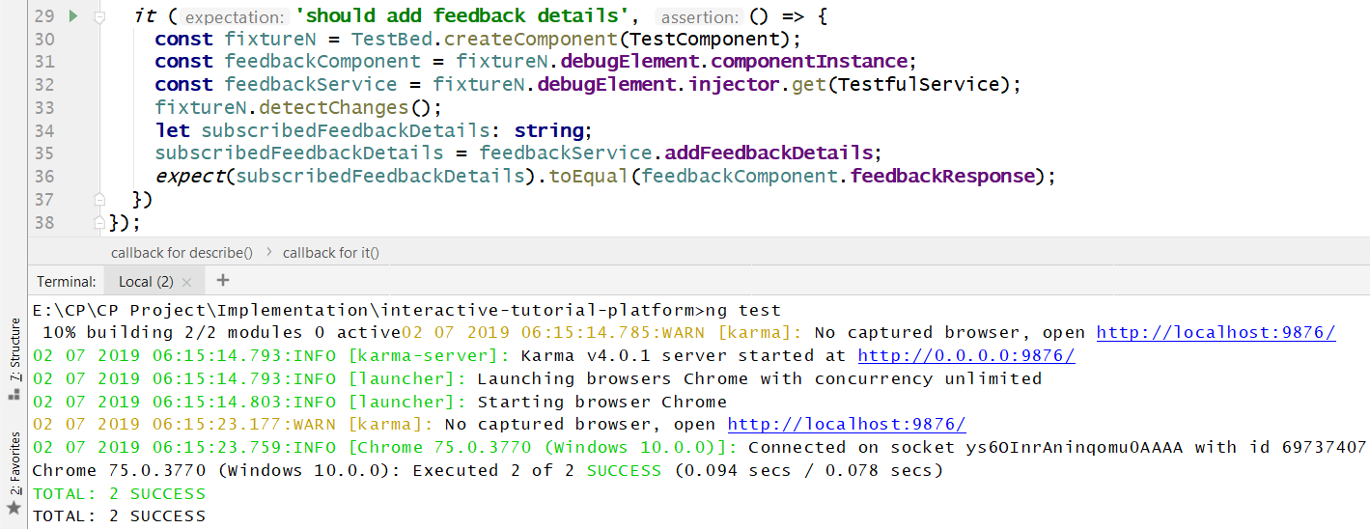

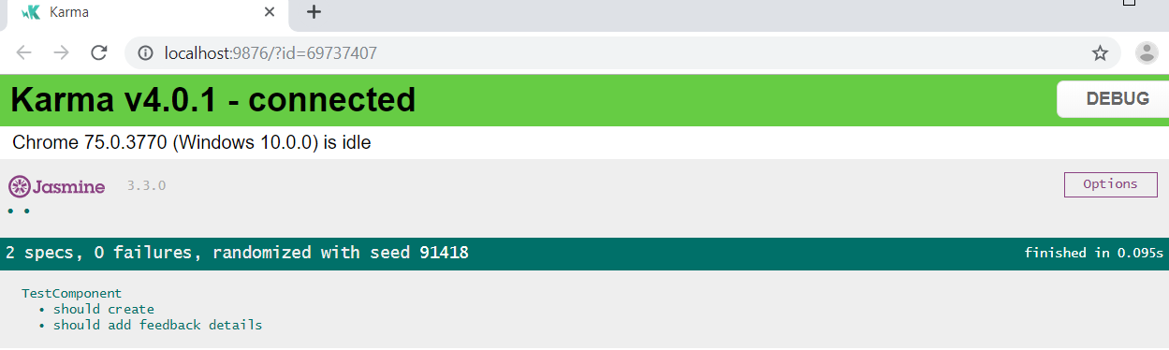

Figure 12: Test case 09 passed result

### Submitting course requests to the admin

|  |  |
| --- | --- |
| Test ID | WT10 |
| Test Purpose | Submitting course request to the admin |
| Expected Result | Successfully sent course request |
| Actual Result | Successfully sent course request |
| Result | Passed |

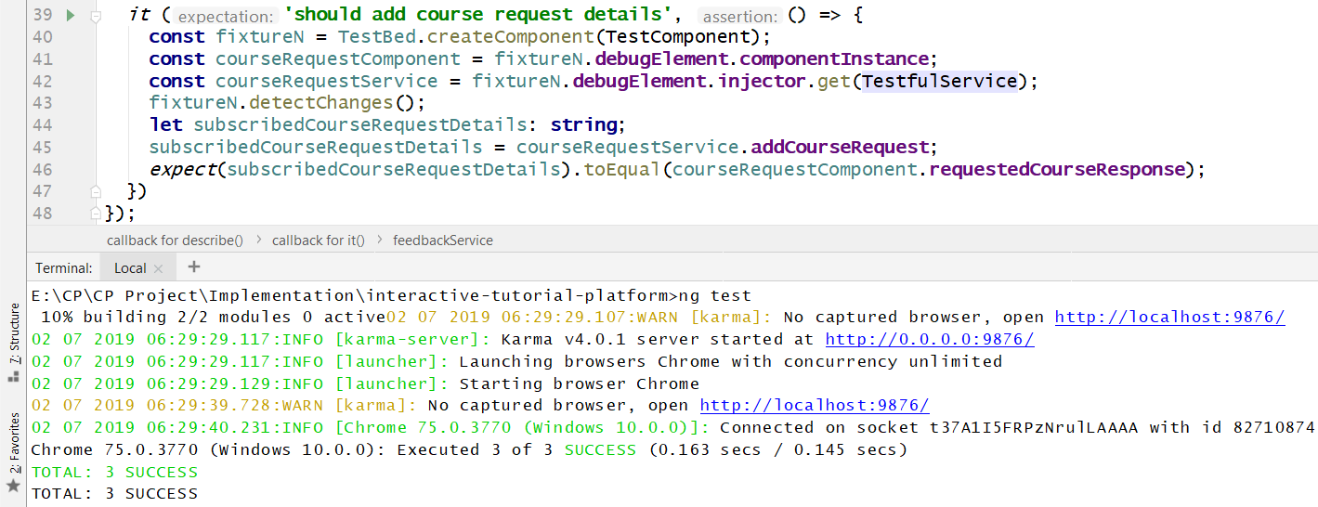

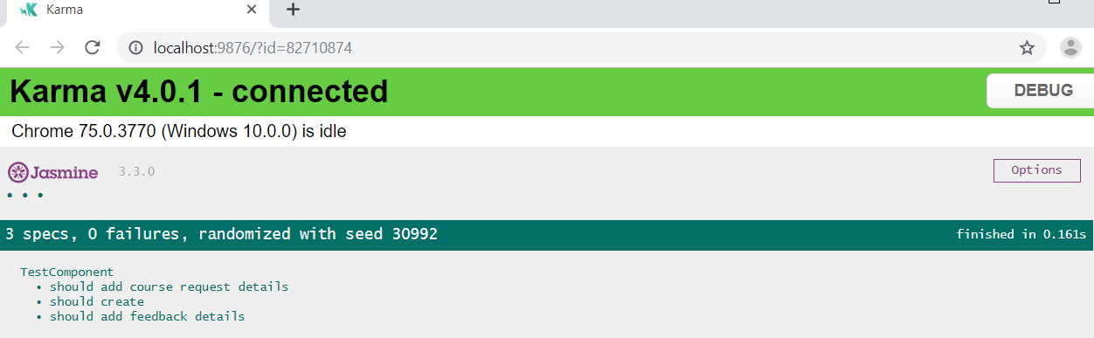

Figure 13: Test case 10 result

## Black box testing

Black Box Testing is a testing process in which the internal code structure is left untouched and only the functional aspect of the software is tested.

### User Registration

|  |  |
| --- | --- |
| Test ID | BT01 |
| Test Purpose | User Registration |
| Expected Result | Successfully added user |
| Actual Result | Successfully added user |
| Result | Passed |

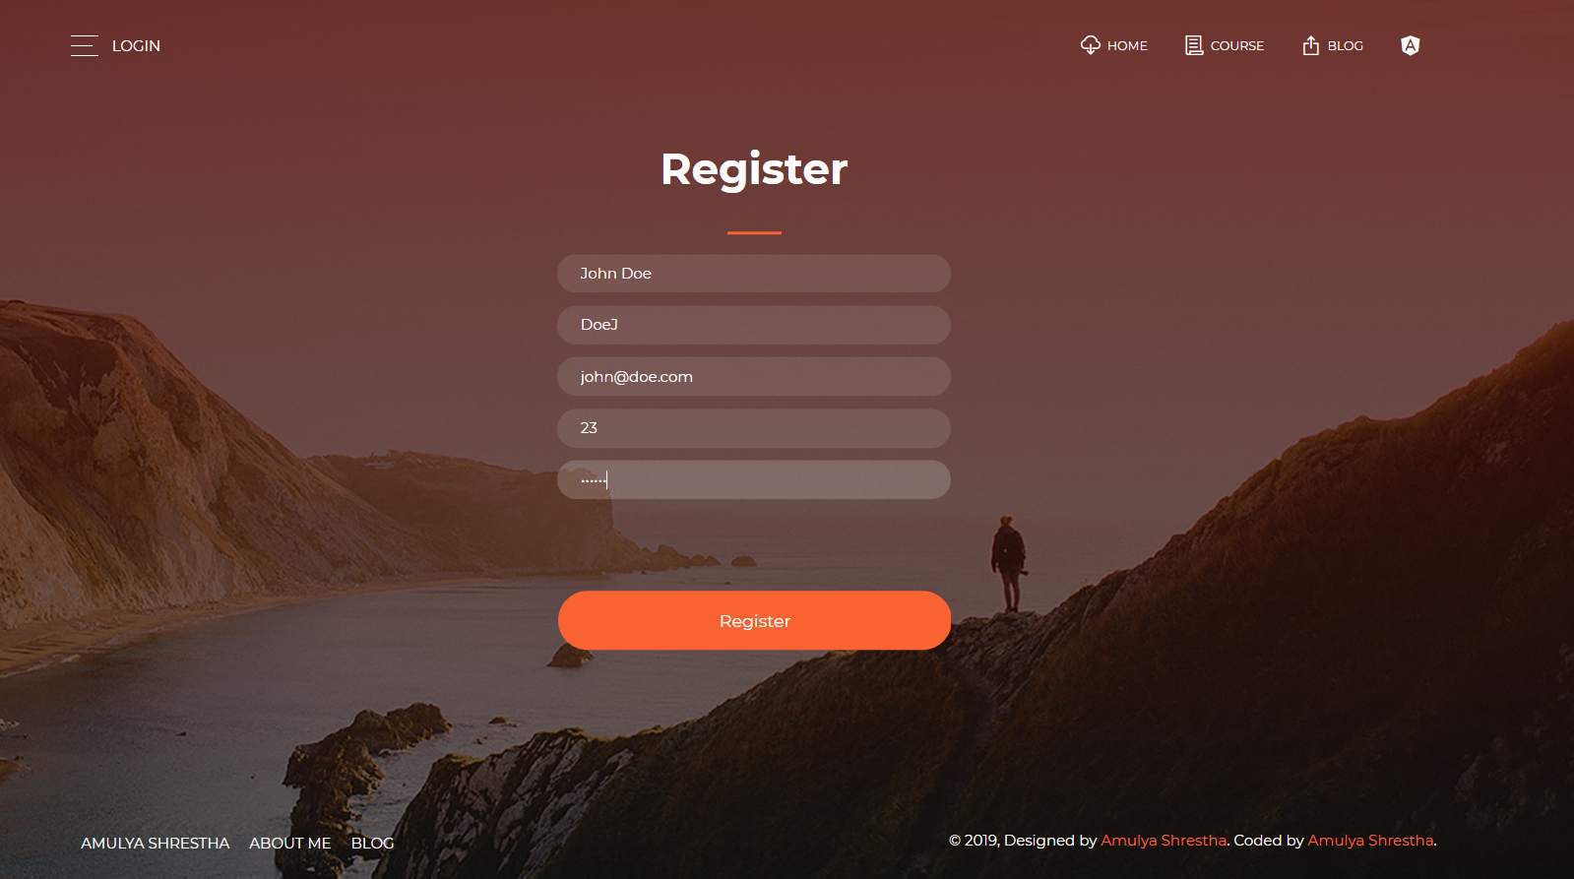

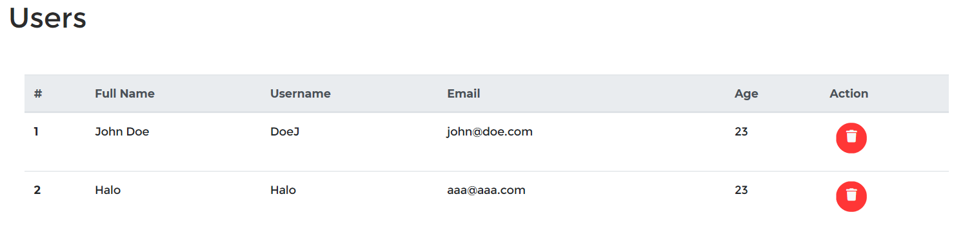

Figure 14: Black box 01 result

### User Login

|  |  |
| --- | --- |
| Test ID | BT02 |
| Test Purpose | User login |
| Expected Result | Successfully logged in user |
| Actual Result | Successfully logged in user |
| Result | Passed |

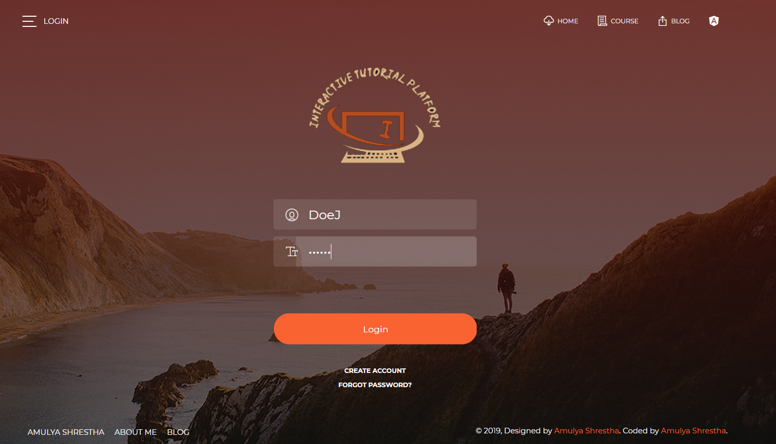



Figure 15: Black box 02 result

### Adding Feedback

|  |  |
| --- | --- |
| Test ID | BT03 |
| Test Purpose | Adding Feedback |
| Expected Result | Successfully sent feedback |
| Actual Result | Successfully sent feedback |
| Result | Passed |

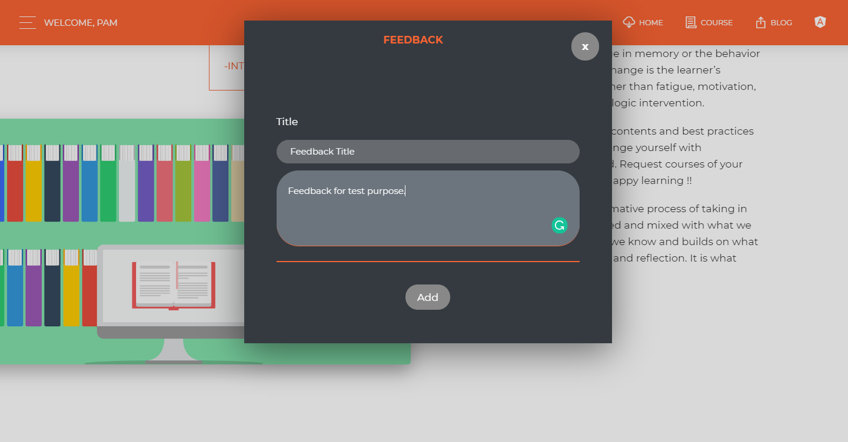

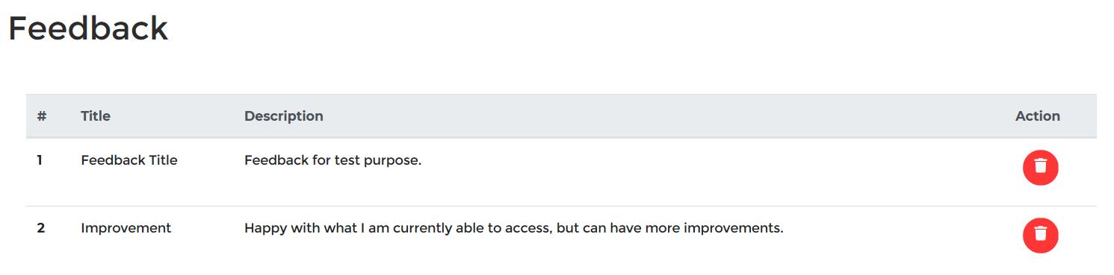

Figure 16: Black box 03 result

### Deleting Feedback

|  |  |
| --- | --- |
| Test ID | BT04 |
| Test Purpose | Deleting feedback |
| Expected Result | Successfully deleted feedback |
| Actual Result | Successfully deleted feedback |
| Result | Passed |

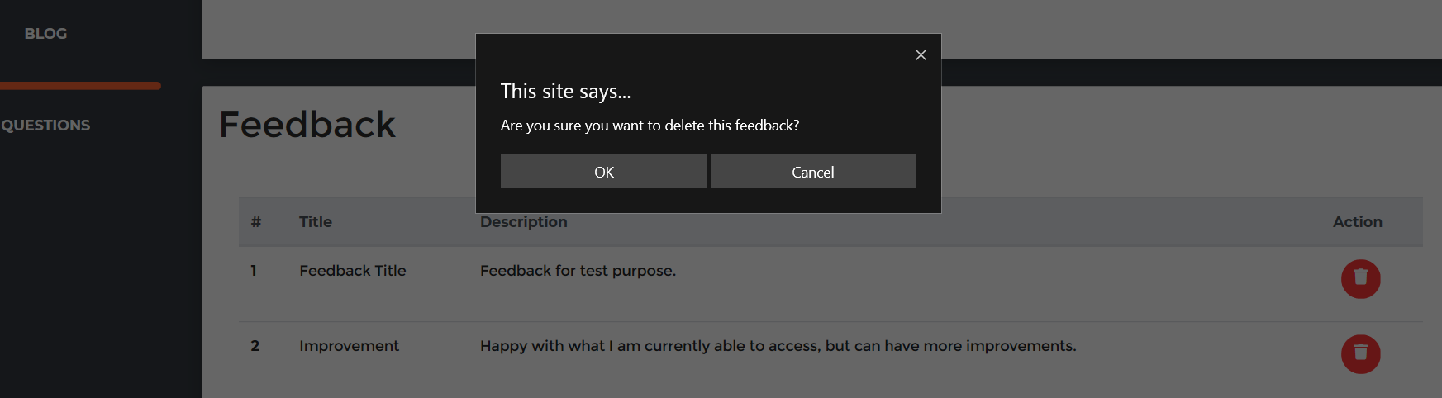

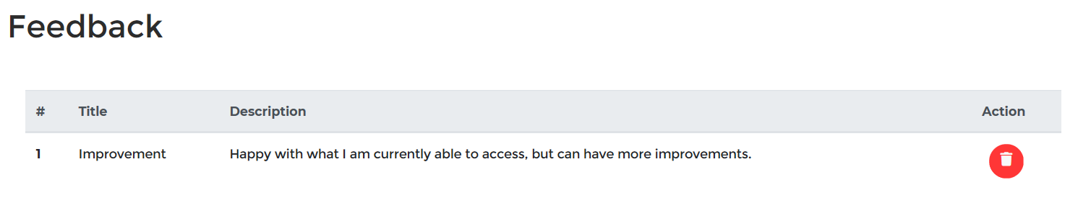

Figure 17: Black box 04 result

### Requesting course

|  |  |
| --- | --- |
| Test ID | BT05 |
| Test Purpose | Requesting course |
| Expected Result | Successfully sent request |
| Actual Result | Successfully sent request |
| Result | Passed |

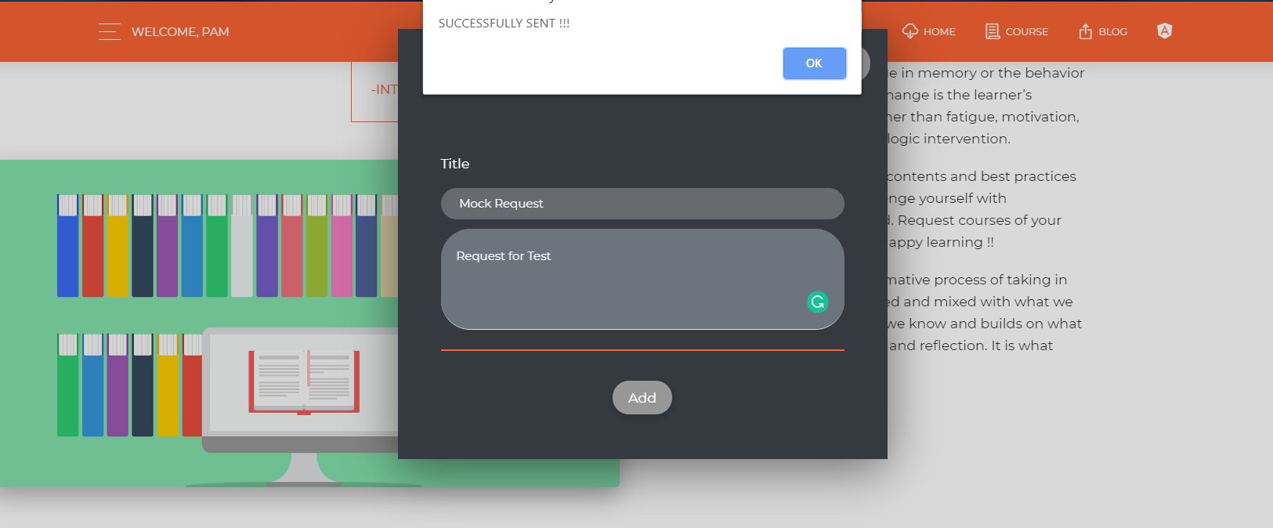

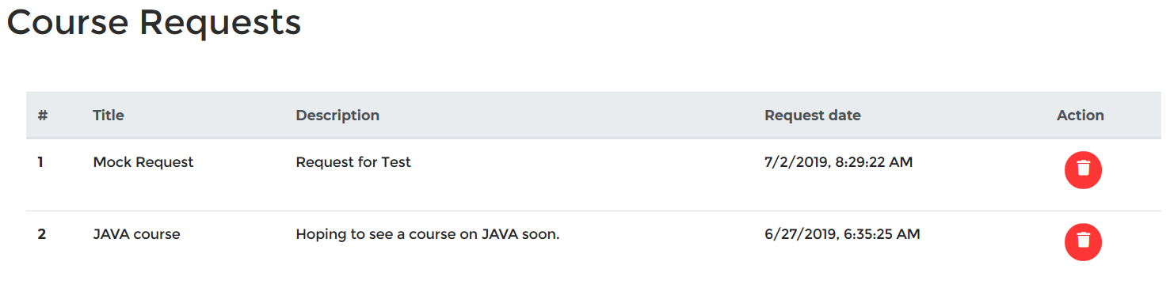

Figure 18: Black box 05 result

### Deleting Requested course

|  |  |
| --- | --- |
| Test ID | BT06 |
| Test Purpose | Deleting requested course |
| Expected Result | Successfully deleted request |
| Actual Result | Successfully deleted request |
| Result | Passed |

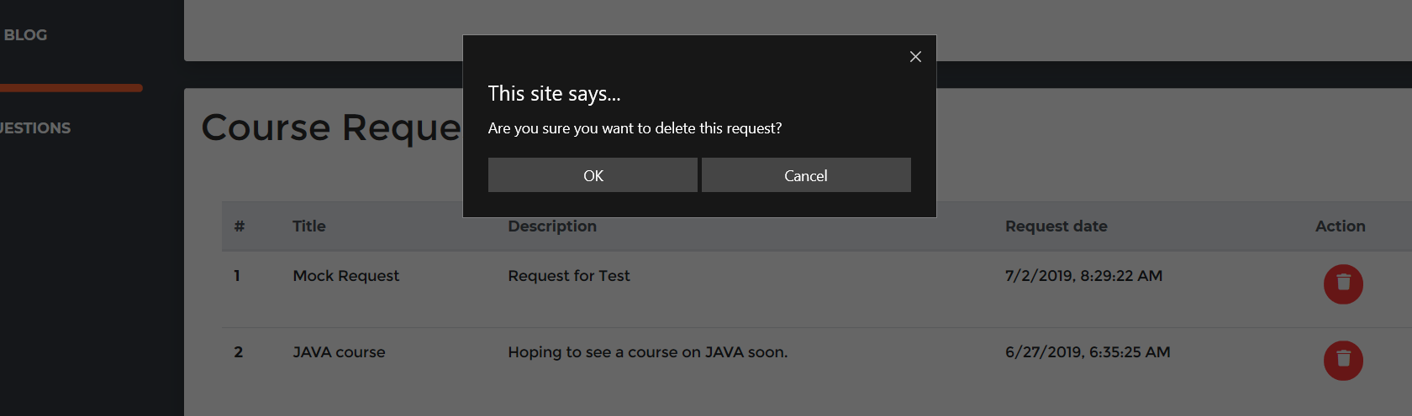

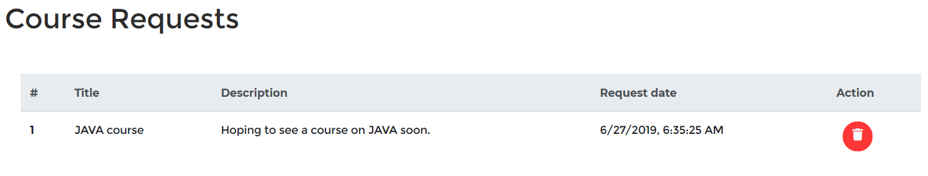

Figure 19: Black box 06 result

### Adding Course

|  |  |
| --- | --- |
| Test ID | BT07 |
| Test Purpose | Adding course |
| Expected Result | Successfully added course |
| Actual Result | Successfully added course |
| Result | Passed |

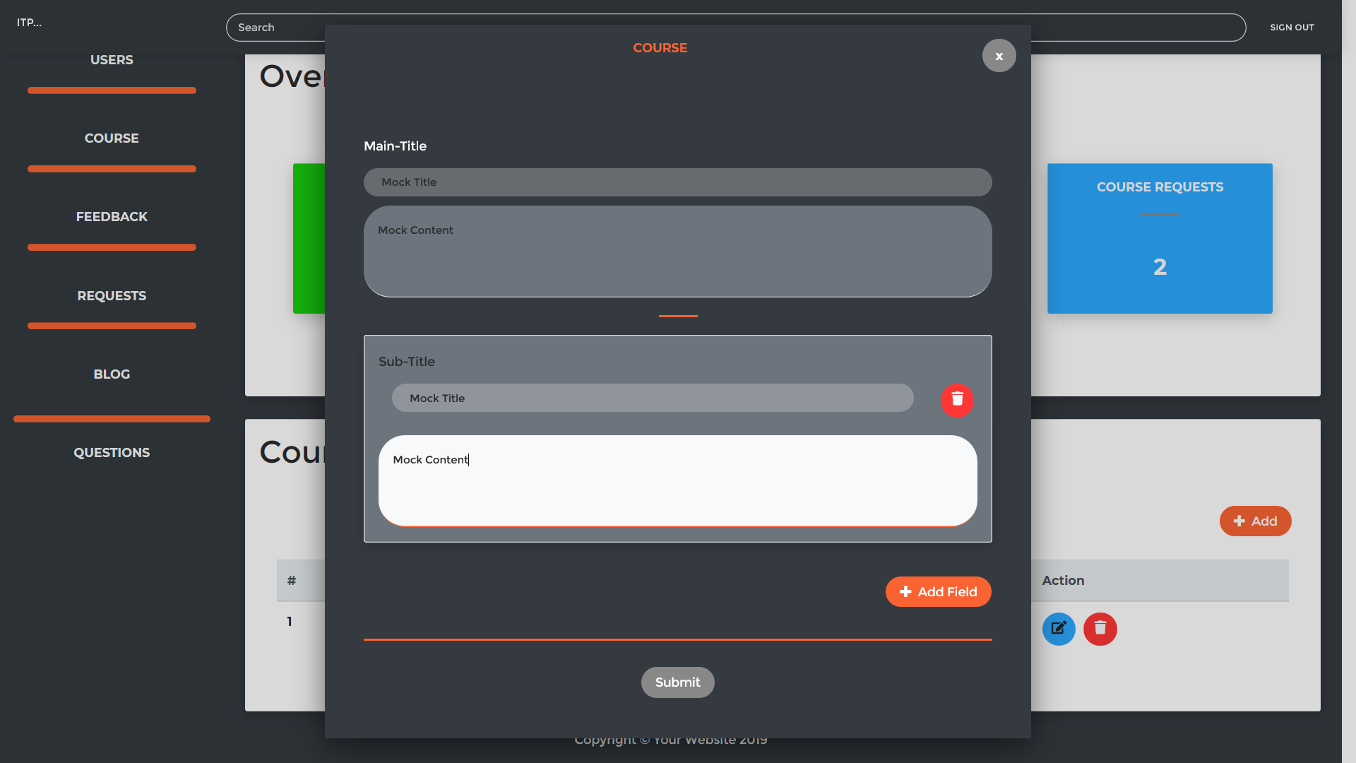

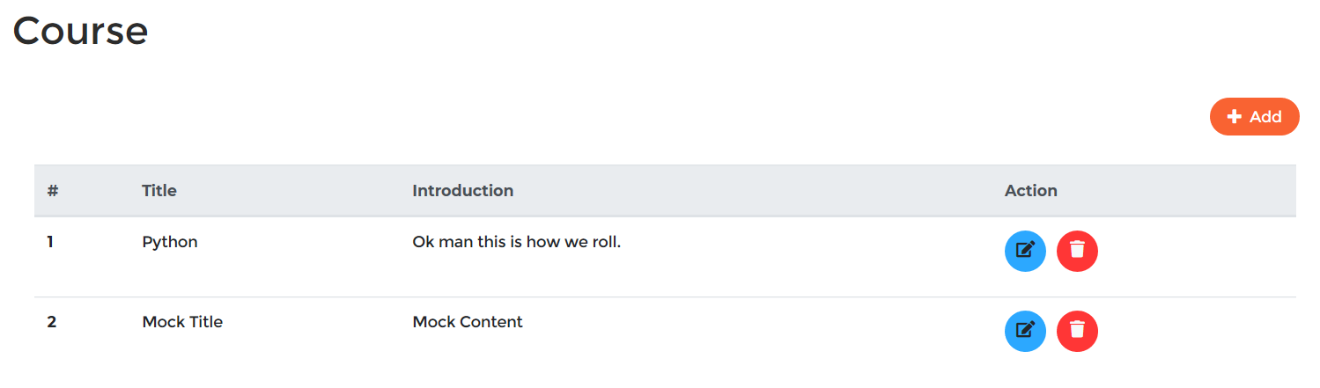

Figure 20: Black box 07 result

### Editing Course

|  |  |
| --- | --- |
| Test ID | BT08 |
| Test Purpose | Editing course |
| Expected Result | Successfully edited course |
| Actual Result | Successfully edited course |
| Result | Passed |

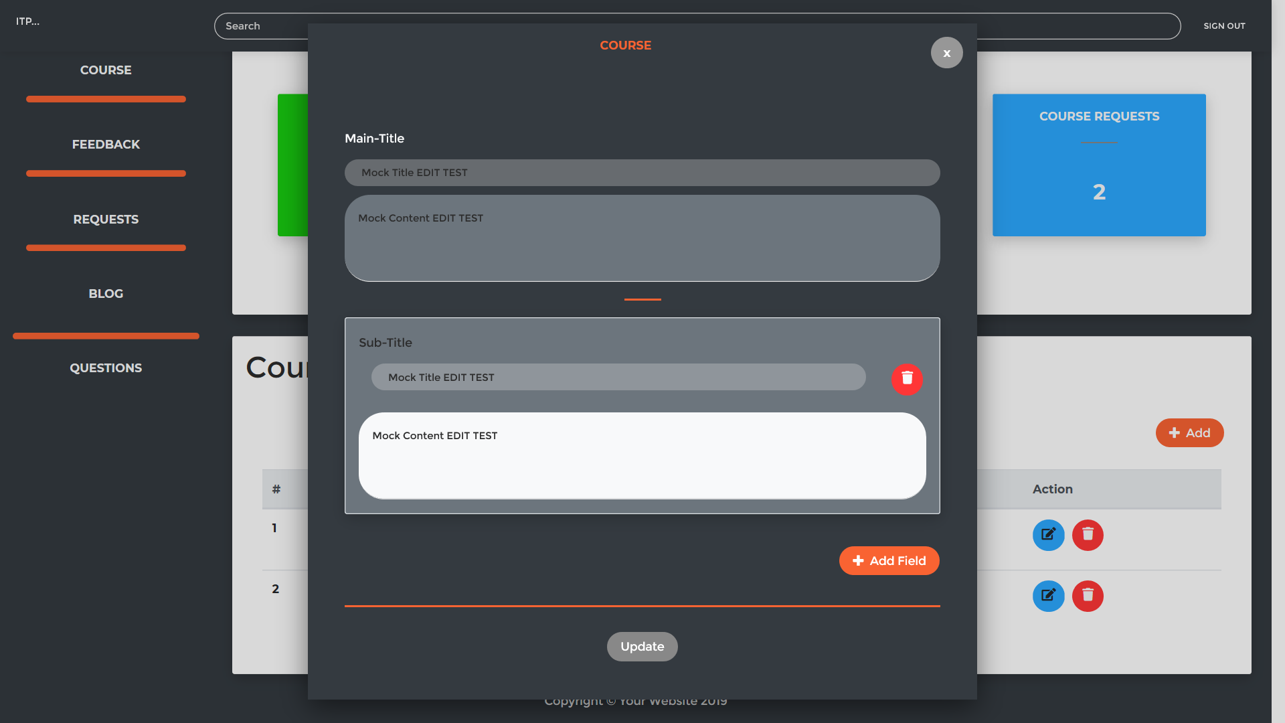

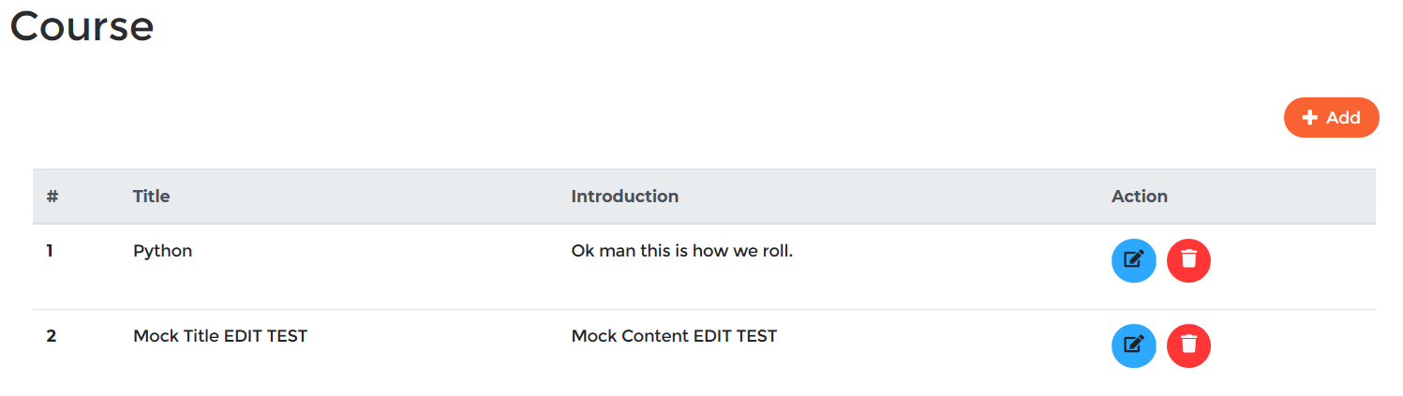

Figure 21: Black box 08 result

### Deleting Course

|  |  |
| --- | --- |
| Test ID | BT09 |
| Test Purpose | Deleting course |
| Expected Result | Successfully deleted course |
| Actual Result | Successfully deleted course |
| Result | Passed |

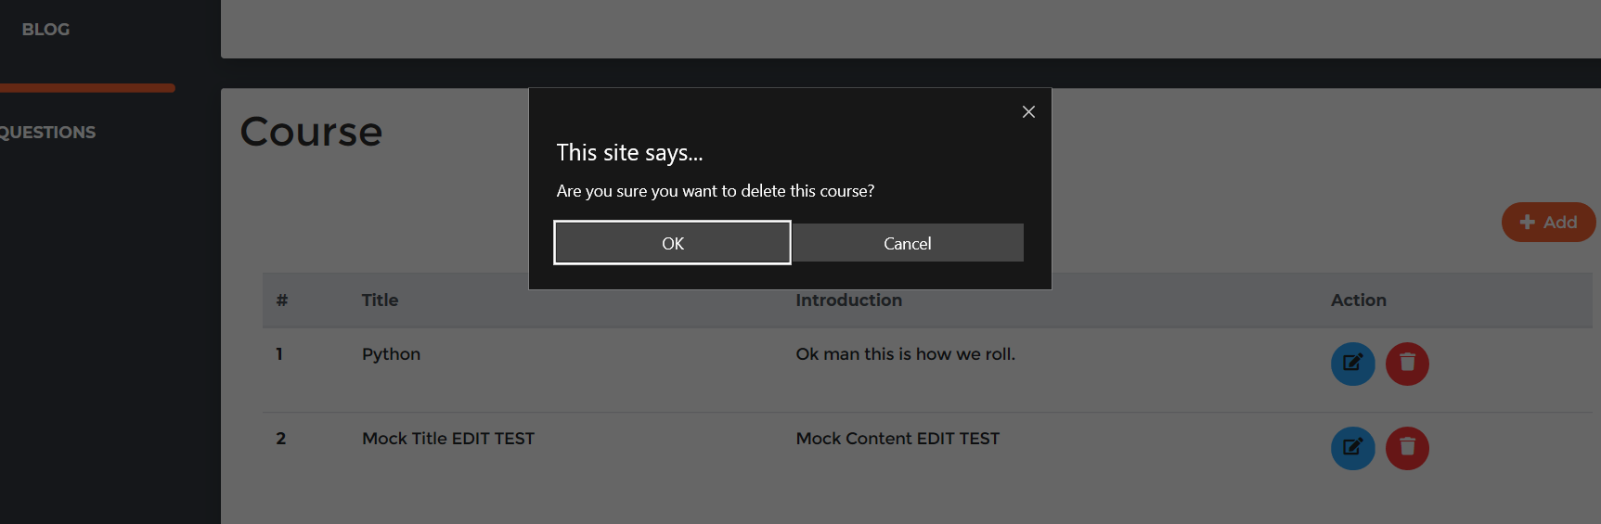

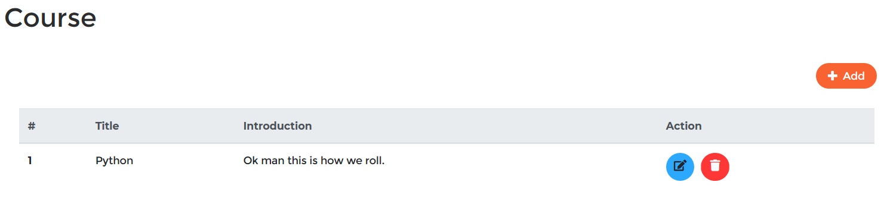

Figure 22: Black box 09 result

### Adding Questions

|  |  |
| --- | --- |
| Test ID | BT10 |
| Test Purpose | Adding question |
| Expected Result | Successfully added questions |
| Actual Result | Successfully added questions |
| Result | Passed |

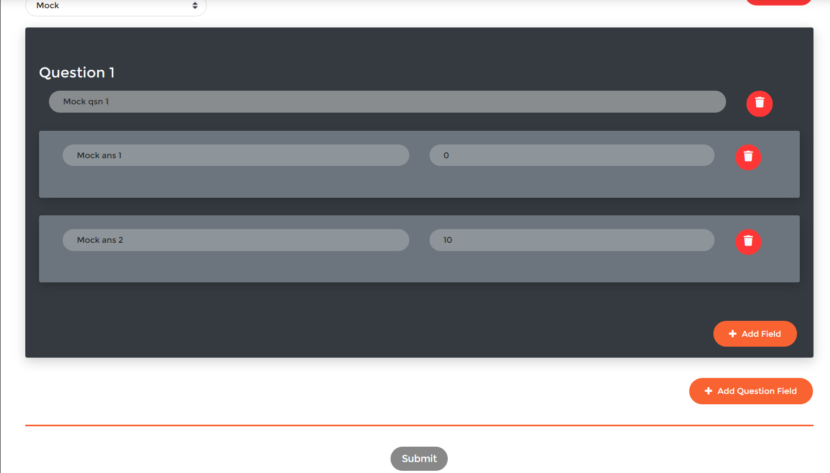

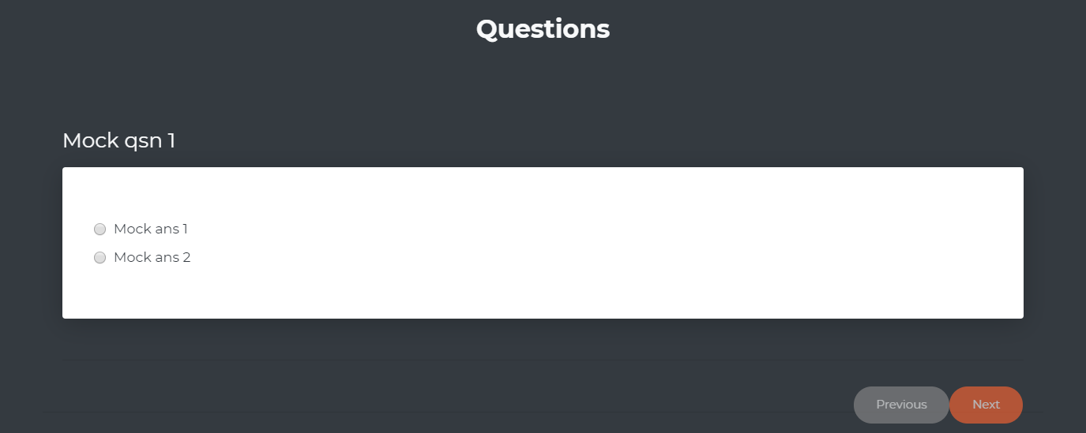

Figure 23: Black box 10 result

### Editing Questions

|  |  |
| --- | --- |
| Test ID | BT11 |
| Test Purpose | Editing question |
| Expected Result | Successfully edited questions |
| Actual Result | Successfully edited questions |
| Result | Passed |

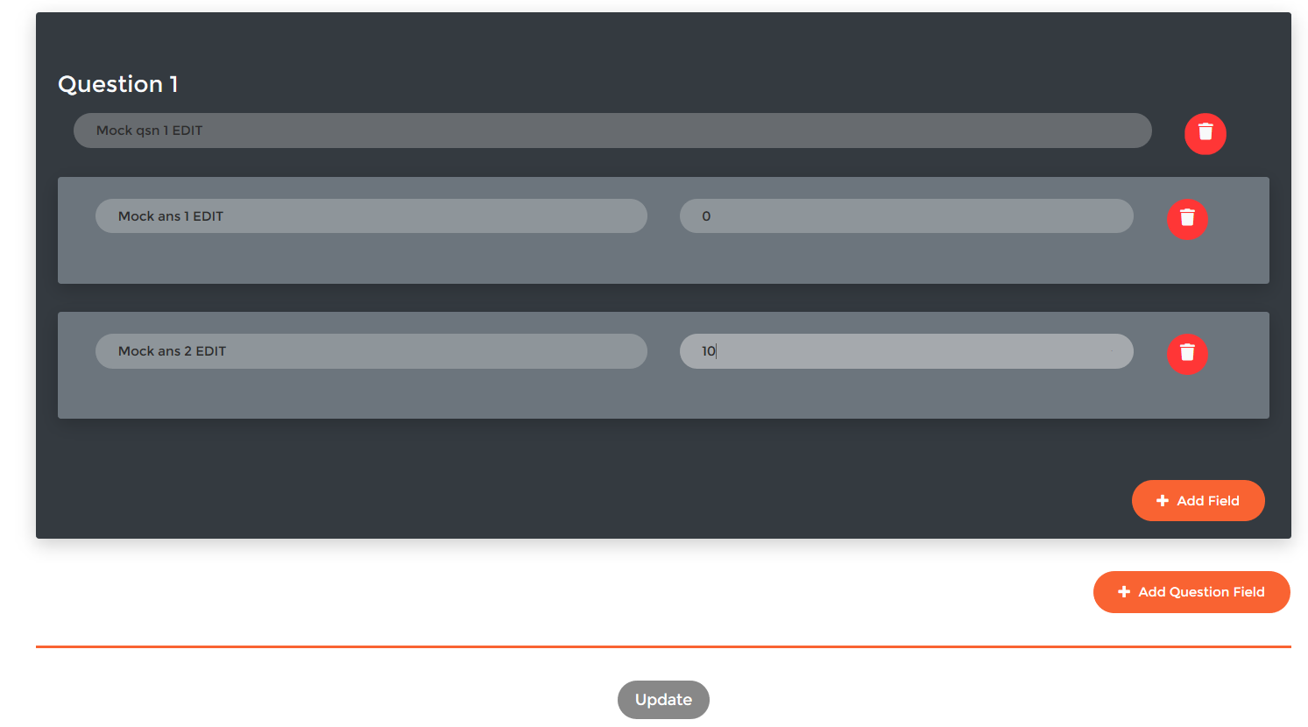

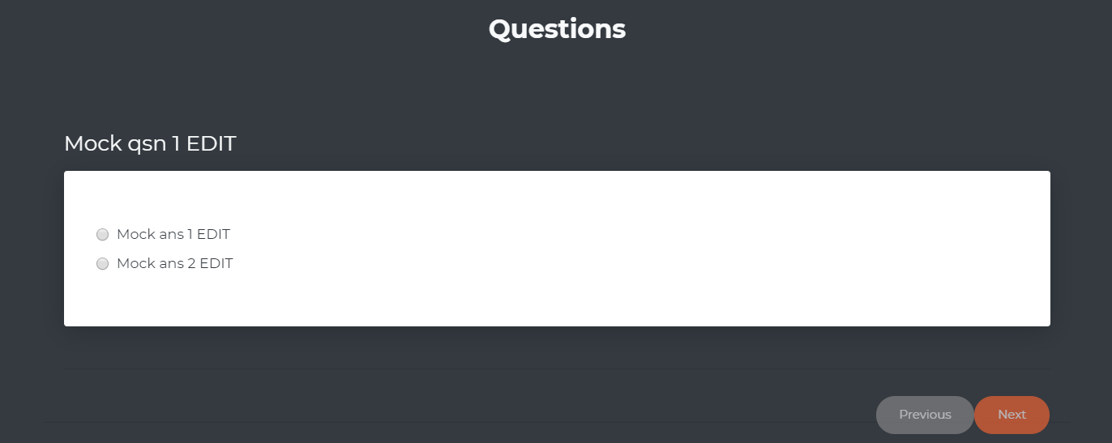

Figure 24: Black box 11 result

### Deleting Questions

|  |  |
| --- | --- |
| Test ID | BT12 |
| Test Purpose | Deleting questions |
| Expected Result | Successfully deleted questions |
| Actual Result | Successfully deleted questions |
| Result | Passed |

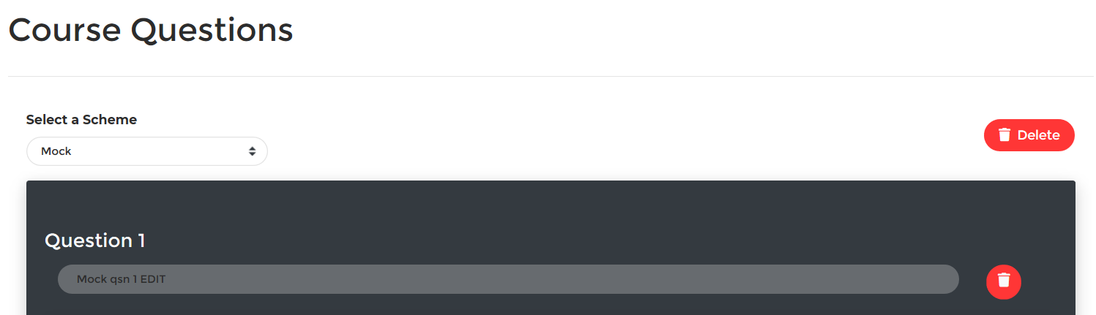

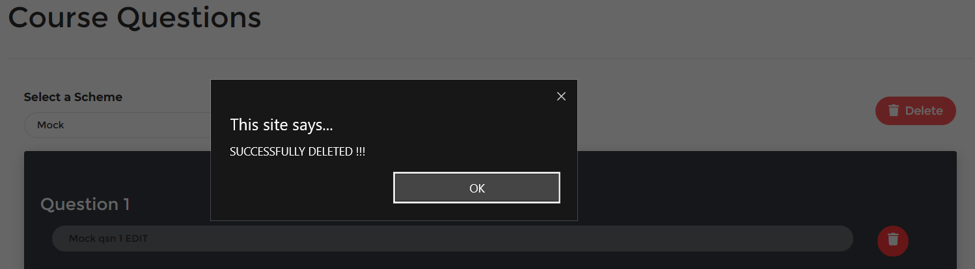

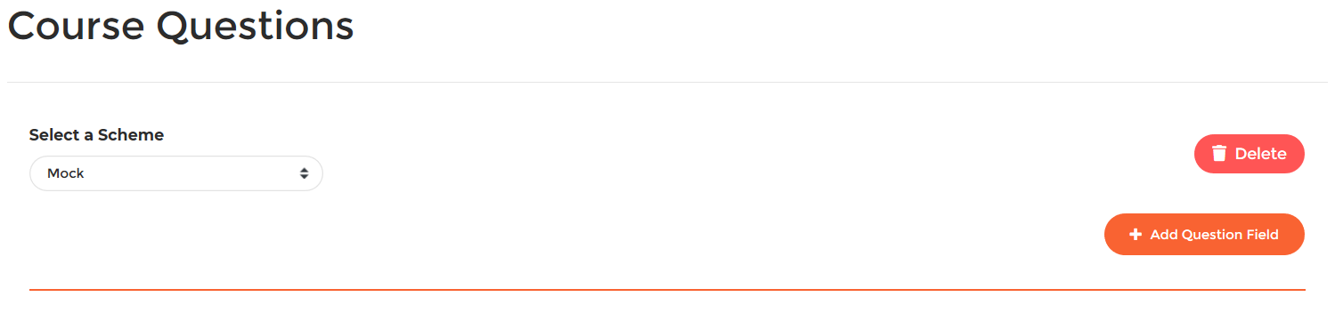

Figure 25: Black box 12 result

### Updating obtained points

|  |  |
| --- | --- |
| Test ID | BT13 |
| Test Purpose | Updating obtained points |
| Expected Result | You obtained <points> out of <total points> |
| Actual Result | You obtained <points> out of <total points> |
| Result | Passed |

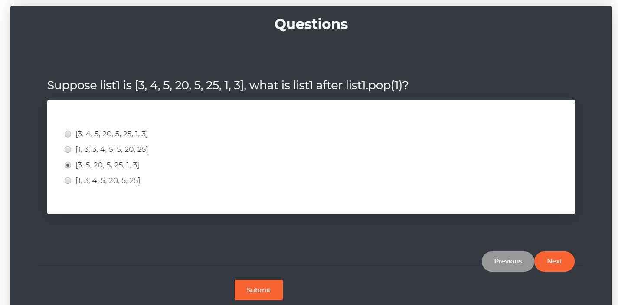

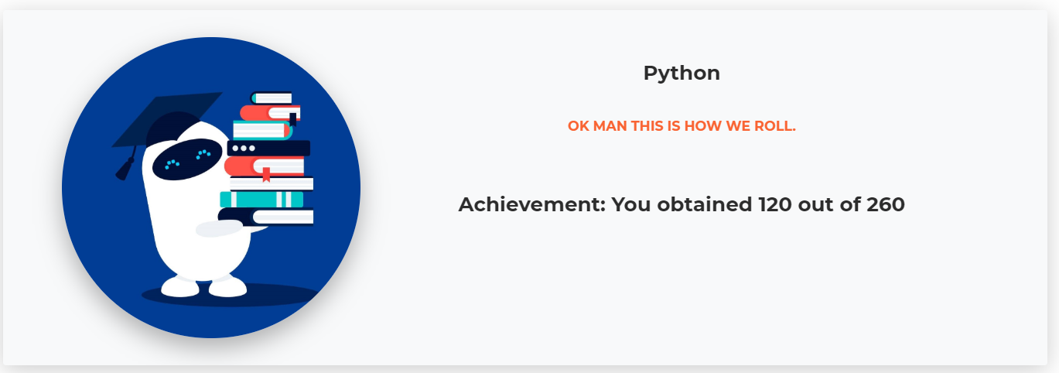

Figure 26: Black box 13 result

### Adding Comment

|  |  |
| --- | --- |
| Test ID | BT14 |
| Test Purpose | Adding comment |
| Expected Result | Successfully added comment |
| Actual Result | Successfully added comment |
| Result | Passed |

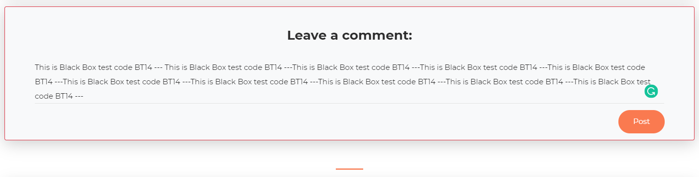

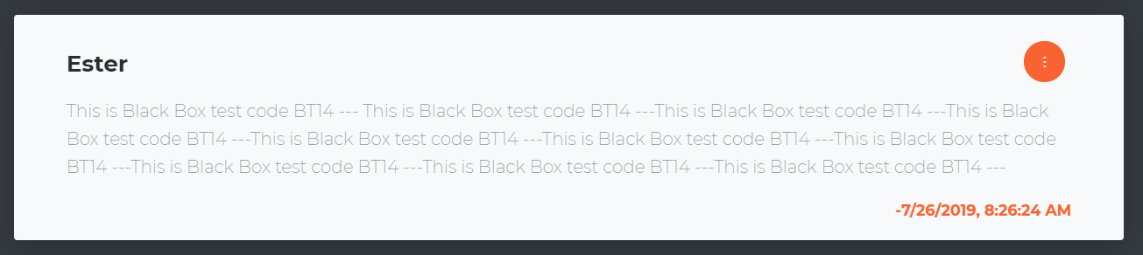

Figure 27: Black box 14 result

### Editing Comment

|  |  |
| --- | --- |
| Test ID | BT15 |
| Test Purpose | Editing comment |
| Expected Result | Successfully edited comment |
| Actual Result | Successfully edited comment |
| Result | Passed |



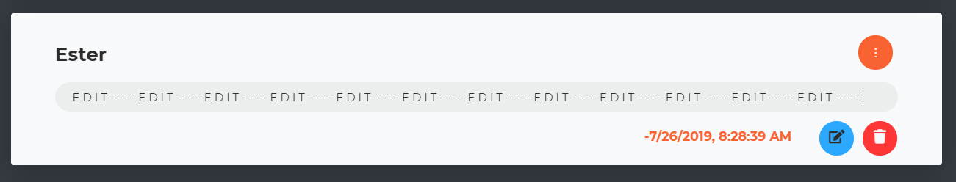

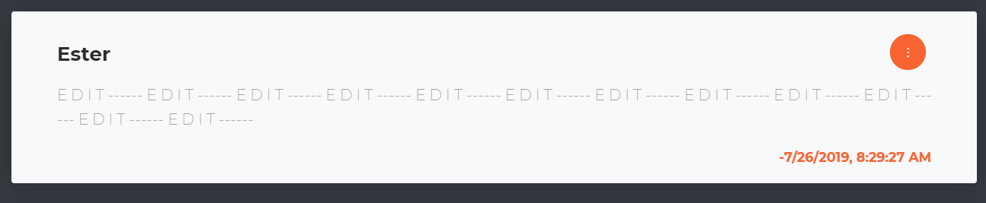

Figure 28: Black box 15 result

### Deleting Comment

|  |  |
| --- | --- |
| Test ID | BT16 |
| Test Purpose | Deleting comment |
| Expected Result | Successfully deleted comment |
| Actual Result | Successfully deleted comment |
| Result | Passed |



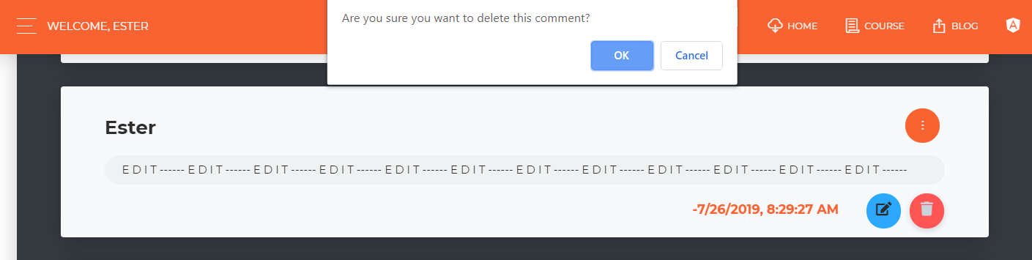



Figure 29: Black box 16 result